New Service Times Johanna will be covering services at Ponsanooth from July. To allow her to attend worship in both Parishes, the PCC has agreed that, from 4th July, we will bring the time of our main Sunday Services forward to 10am.

Lateral Flow Testing To protect everyone in this current Covid outbreak, Johanna is now testing regularly. Anyone can order tests for themselves from www.gov.uk/order-coronavirus-rapid-lateral-flow-tests

Next week:
Wednesday 23 June
10.00 Celtic Morning Prayer at St Michael

Sunday 27 June 2021
4th Sunday after Trinity
10.30 Communion at St Mawnan
Readings
Psalm 30
Lamentations 3.22–33 - Catherine
Mark 5.21–end - Ian
Intercessions - David
Hymns
249. Great is thy faithfulness
Iona. Jairus’s Daughter
130. Come, wounded healer

Our Services from July
St Michael - open Weds & Sun
Carwinion Road - TR11 5JG
2nd Sunday of each month
8.00 BCP Communion
10.00 Morning Prayer
3rd Sunday of each month:
10.00 Morning Prayer

1st, 3rd & 5th Wednesdays of each month:
10.00 BCP Communion
2nd & 4th Wednesdays:
10.00 Celtic Morning Prayer

St Mawnan– open most days
Church Road - TR11 5HY
1st, 3rd & 5th Sundays 10.00 Communion

Priest in Charge: Rev Johanna Clare:
rev.johanna.clare@gmail.com - 07919 186307
Website: stmawnan.org
Facebook: St Mawnan and St Michael
St Mawnan, Church Road, TR11 5HY
St Michael, Carwinion Road, TR11 5JG



Mawnan Parish

Sunday 20 June 2021
3rd Sunday after Trinity

10.30 Communion at St Mawnan
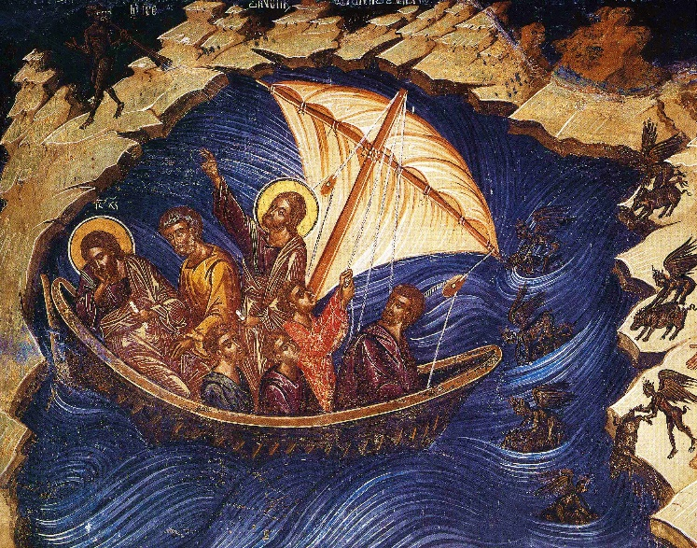
Stilling the storm

21 All people that on earth do dwell

Collect
God our saviour,
look on this wounded world
in pity and in power;
hold us fast to your promises of peace
won for us by your Son,
our Saviour Jesus Christ.
Job 38.1–11 -David
38 Then the Lord answered Job out of the whirlwind:
² ‘Who is this that darkens counsel by words without knowledge?
³ Gird up your loins like a man,
I will question you, and you shall declare to me.
⁴ ‘Where were you when I laid the foundation of the earth?
Tell me, if you have understanding.
⁵ Who determined its measurements—surely you know!
Or who stretched the line upon it?
⁶ On what were its bases sunk,
or who laid its cornerstone
⁷ when the morning stars sang together
and all the heavenly beings shouted for joy?

⁸ ‘Or who shut in the sea with doors
when it burst out from the womb?—
⁹ when I made the clouds its garment,
and thick darkness its swaddling band,
¹⁰ and prescribed bounds for it,
and set bars and doors,
¹¹ and said, “Thus far shall you come, and no farther,
and here shall your proud waves be stopped”?

2 Corinthians 6.1–13 - Catherine
6 As we work together with him, we urge you also not to accept the grace of God in vain. ² For he says,
‘At an acceptable time I have listened to you,
and on a day of salvation I have helped you.’
See, now is the acceptable time; see, now is the day of salvation! ³ We are putting no obstacle in anyone’s way, so that no fault may be found with our ministry, ⁴ but as servants of God we have commended ourselves in every way: through great endurance, in afflictions, hardships, calamities, ⁵ beatings, imprisonments, riots, labours, sleepless nights, hunger; ⁶ by purity, knowledge, patience, kindness, holiness of spirit, genuine love, ⁷ truthful speech, and the power of God; with the weapons of righteousness for the right hand and for the left; ⁸ in honour and dishonour, in ill repute and good repute. We are treated as impostors, and yet are true; ⁹ as unknown, and yet are well known; as dying, and see—we are alive; as punished, and yet not killed; ¹⁰ as sorrowful, yet always rejoicing; as poor, yet making many rich; as having nothing, and yet possessing everything.
¹¹ We have spoken frankly to you Corinthians; our heart is wide open to you. ¹² There is no restriction in our affections, but only in yours. ¹³ In return—I speak as to children—open wide your hearts also.

Mark 4.35–41
Jesus Stills a Storm
35 On that day, when evening had come, he said to them, ‘Let us go across to the other side.’ ³⁶And leaving the crowd behind, they took him with them in the boat, just as he was. Other boats were with him. ³⁷A great gale arose, and the waves beat into the boat, so that the boat was already being swamped. ³⁸But he was in the stern, asleep on the cushion; and they woke him up and said to him, ‘Teacher, do you not care that we are perishing?’ ³⁹He woke up and rebuked the wind, and said to the sea, ‘Peace! Be still!’ Then the wind ceased, and there was a dead calm. ⁴⁰He said to them, ‘Why are you afraid? Have you still no faith?’ ⁴¹And they were filled with great awe and said to one another, ‘Who then is this, that even the wind and the sea obey him?’

Intercessions - Libby
For our Prayers:
Val Ackland, Paul Bryer, Susan Anderson’s granddaughter Sarah, Nick Bailey, David Sanderson, Shirley Banks, Sylvia Weatherhead, Emma Chesshire, Dennis and Louise Gartside, and Ann Benney snr, and others known to us who especially need our prayers.
Our school, the NHS, key workers, and our leaders.
Sylvia and Owen who are getting married on 25th June, and Tim and Clare, whose Banns we are reading this month.
We remember those who have died including Peter Bennett, and we pray for all who mourn.

281 He who would valiant be

Post Communion
O God, whose beauty is beyond our imagining
and whose power we cannot comprehend:
show us your glory as far as we can grasp it,
and shield us from knowing more than we can bear
until we may look upon you without fear;
through Jesus Christ our Saviour.

153 Eternal Father strong to save

Notices
Peter Bennett’s Funeral will be at St Michael’s Church at 10.30 on Monday 21 June. Please let Johanna or Heather know if you are planning to attend. The service from the crematorium at 12 noon will be webcast:
Username hipi0972, Password 742149
Website www.obitus.com

Cleaning at St Mawnan: we now have a team of people sharing the cleaning at St Michael. It would be very helpful if we could have a rota of cleaners for St Mawnan. Please speak to Libby if you might take part.

Food Bank This week’s needs: Decaf Coffee, Tinned Spaghetti, Tinned Hotdogs, Noodles, Tinned Potatoes, Jam, Toilet Rolls, Beans and Sausages, Dry Cat Food, Shampoo, Baby Wipes, Shaving Foam, Male/Female Deodorant, Washing Tablets, Washing up Liquid, Shower Gel, Sugar, Sweets, Long Life Milk.
You can drop off items at Asda (only things bought instore) or directly to the Foodbank on Mondays between 10am and 1pm and on Thursdays from 2pm until 4pm.

Monthly Deanery Prayer Meeting Tuesday 19th July at 7pm at All Saints Falmouth

