Deanery Prayer Meeting Tuesday 19 July at 7pm at Falmouth, All Saints.

New Service Times Johanna will be covering services at Ponsanooth from July. To allow her to attend worship in both Parishes, the PCC has agreed that Mawnan will bring the time of their main Sunday Services forward to 10.00. Ponsanooth’s services will continue at 11.15.

Next week:
Monday 19 July
19.00 Deanery Prayer at All Saints, Falmouth
Wednesday 21 July
10.00 BCP Communion at Mawnan, St Michael
19.00 Mawnan PCC via Zoom

Sunday 25 July 2021 - James the Apostle
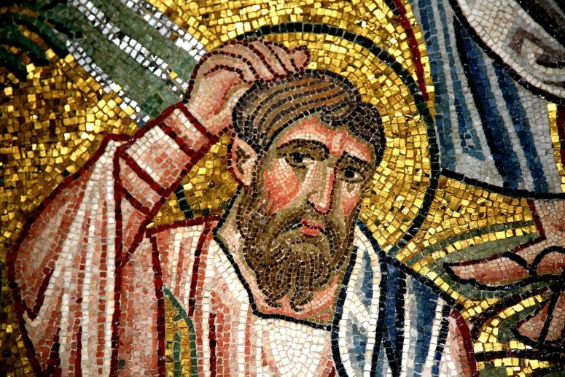
10.00 Morning Prayer at Mawnan, St Michael
Readings
Psalm 126
Acts 11.27—12.2 - David
Matthew 20.20–28 - Jenny
Intercessions - Catherine
Hymns
73. Bless and keep us God
88. Brother, sister let me serve you
352. Jesus is Lord! Creation's voice proclaims it
281. He who would valiant be

11.15 Communion at Ponsanooth

Priest in Charge: Rev Johanna Clare:
rev.johanna.clare@gmail.com - 07919 186307
St Mawnan, Church Road, TR11 5HY
Mawnan, St Michael, Carwinion Road, TR11 5JG
Ponsanooth, St Michael and All Angels,
St Michael’s Road, TR3 7ES
Website: stmawnan.org
Facebook: St Mawnan and St Michael
Mawnan & Ponsanooth
Sunday 18 July 2021 7th Sunday after Trinity
The Good Shepherd
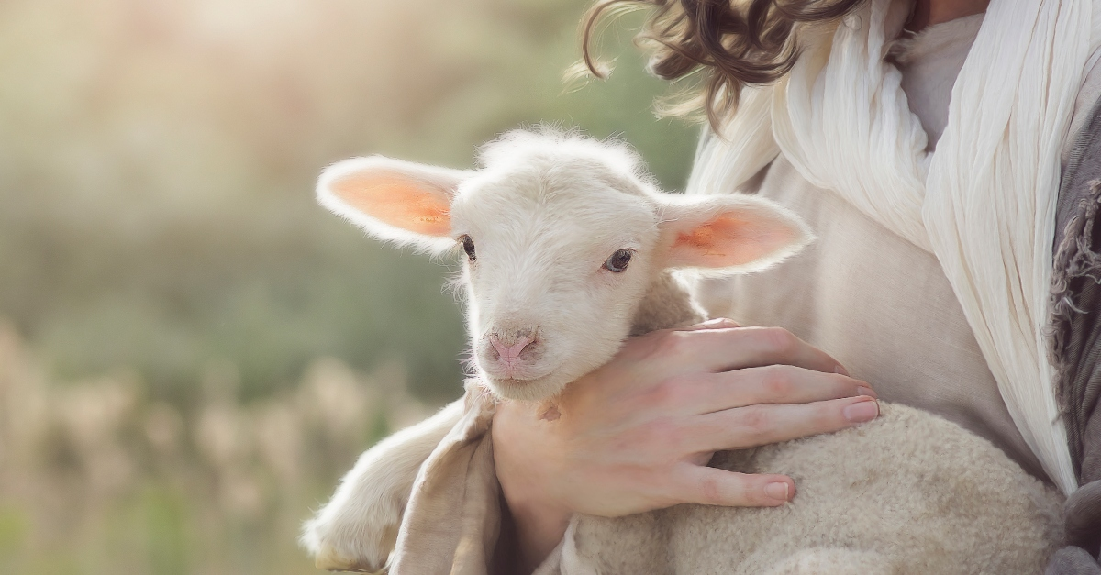
10.00 Communion at St Mawnan
Readings
Jeremiah 23.1–6 - Catherine
Ephesians 2.11–end - David
Mark 6.30–34, 53–end
Intercessions – Libby
Hymns
636 The church’s one foundation
422 Lord we come to ask your healing
19 All my hope on God is founded

This week’s Readings and Prayers
Collect
Generous God,
you give us gifts and make them grow:
though our faith is small as mustard seed,
make it grow to your glory
and the flourishing of your kingdom;
through Jesus Christ our Lord.
Jeremiah 23.1–6
23 Woe to the shepherds who destroy and scatter the sheep of my pasture! says the Lord. ² Therefore, thus says the Lord, the God of Israel, concerning the shepherds who shepherd my people: It is you who have scattered my flock, and have driven them away, and you have not attended to them. So I will attend to you for your evil doings, says the Lord. ³ Then I myself will gather the remnant of my flock out of all the lands where I have driven them, and I will bring them back to their fold, and they shall be fruitful and multiply. ⁴ I will raise up shepherds over them who will shepherd them, and they shall not fear any longer, or be dismayed, nor shall any be missing, says the Lord.
⁵ The days are surely coming, says the Lord, when I will raise up for David a righteous Branch, and he shall reign as king and deal wisely, and shall execute justice and righteousness in the land. ⁶ In his days Judah will be saved and Israel will live in safety. And this is the name by which he will be called: ‘The Lord is our righteousness.’

Ephesians 2.11–end
¹¹ So then, remember that at one time you Gentiles by birth, called ‘the uncircumcision’ by those who are called ‘the circumcision’—a physical circumcision made in the flesh by human hands— ¹² remember that you were at that time without Christ, being aliens from the commonwealth of Israel, and strangers to the covenants of promise, having no hope and without God in the world. ¹³ But now in Christ Jesus you who once were far off have been brought near by the blood of Christ. ¹⁴ For he is our peace; in his flesh he has made both groups into one and has broken down the dividing wall, that is, the hostility between us. ¹⁵ He has abolished the law with its commandments and ordinances, so that he might create in himself one new humanity in place of the two, thus making peace, ¹⁶ and might reconcile both groups to God in one body through the cross, thus putting to death that hostility through it. ¹⁷ So he came and proclaimed peace to you who were far off and peace to those who were near; ¹⁸ for through him both of us have access in one Spirit to the Father. ¹⁹ So then you are no longer strangers and aliens, but you are citizens with the saints and also members of the household of God, ²⁰ built upon the foundation of the apostles and prophets, with Christ Jesus himself as the cornerstone. ²¹ In him the whole structure is joined together and grows into a holy temple in the Lord; ²² in whom you also are built together spiritually into a dwelling-place for God.

Psalm 23
1 The Lord is my shepherd; •
therefore can I lack nothing.
2 He makes me lie down in green pastures •
and leads me beside still waters.
3 He shall refresh my soul •
and guide me in the paths of righteousness for his name’s sake.
4 Though I walk through the valley of the shadow of death,
I will fear no evil; •
for you are with me;
your rod and your staff, they comfort me.
5 You spread a table before me
in the presence of those who trouble me; •
you have anointed my head with oil
and my cup shall be full.
6 Surely goodness and loving mercy shall follow me
all the days of my life, •
and I will dwell in the house of the Lord for ever.

Mark 6.30–34, 53–end
³⁰ The apostles gathered around Jesus, and told him all that they had done and taught. ³¹ He said to them, ‘Come away to a deserted place all by yourselves and rest a while.’ For many were coming and going, and they had no leisure even to eat. ³² And they went away in the boat to a deserted place by themselves. ³³ Now many saw them going and recognized them, and they hurried there on foot from all the towns and arrived ahead of them. ³⁴ As he went ashore, he saw a great crowd; and he had compassion for them, because they were like sheep without a shepherd; and he began to teach them many things.
⁵³ When they had crossed over, they came to land at Gennesaret and moored the boat. ⁵⁴ When they got out of the boat, people at once recognized him, ⁵⁵ and rushed about that whole region and began to bring the sick on mats to wherever they heard he was. ⁵⁶ And wherever he went, into villages or cities or farms, they laid the sick in the market-places, and begged him that they might touch even the fringe of his cloak; and all who touched it were healed.
Post Communion
Lord God, whose Son is the true vine and the source of life,
ever giving himself that the world may live:
may we so receive within ourselves the power of his death and passion
that, in his saving cup, we may share his glory and be made perfect in his love;
for he is alive and reigns, now and for ever.

For our Prayers: Ponsanooth & Mawnan
Jeanette Edwards, Val Ackland, Paul Bryer, Nick Bailey, Shirley Banks, Sylvia Weatherhead, Emma Chesshire, Sarah, Dennis and Louise Gartside, Ann Benney snr, Hazel Dobson, Toni Thomas, Arthur and Brenda Rule, and others known to us who especially need our prayers.
We remember those who have died including Doug Sherratt, Peter Bennett and Rosemary Stamp, and we pray for all who mourn.
Our schools, the NHS, key workers, and our leaders.
Saltren and Charlotte, and Samantha and Richard, whose Banns we are reading this month.

Notices
Food Bank: This week’s needs: Washing tablets, Shower gel, Sweets, Shaving foam, Shampoo, Baby wipes, Tinned meat, Long life milk, Coffee, Tea bags (not loose tea), Tinned carrots, Tinned potatoes, Savoury biscuits, Meat soup, Coffee whitener.
NOT CURRENTLY NEEDED: Soup, Pasta’ Beans
Chopped tomatoes.

Cleaning at St Mawnan: we now have a team of people sharing the cleaning at Mawnan, St Michael. It would be very helpful if we could have a rota of cleaners for St Mawnan. Please speak to Libby if you might take part.

