New Covid Rules From 19 July, we recommend that we continue to wear facemasks, use sanitiser, and register with the Test and Trace system. Communion will be offered in one kind (the wafer) only and brought to you in your seat. We will share the peace with a wave. The area at the back of Church is to only be used by those who are strictly wearing masks, maintaining social distancing, and not singing

Next week:
Wednesday 28 July
10.00 Celtic MP at Mawnan, St Michael
19.00 Leading Your Church into Growth (via Zoom)

Sunday 1 August 2021
9th Sunday after Trinity
Bread from Heaven
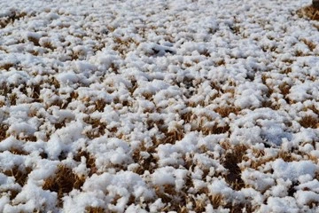
10.00 Communion at St Mawnan
Readings
Exodus 16.2–4, 9–15 - Caroline
Ephesians 4.1–16 - John
John 6.24–35
Intercessions - David
Hymns
205 Glorious things of thee are spoken
584 Rock of ages
374 Just as I am
252 Guide me O thou great Redeemer

10.45 Methodist Service in the Café at Ponsanooth Hall

Rev Johanna Clare
(working days Tuesday, Wednesday, Thursday)
rev.johanna.clare@gmail.com - 07919 186307
St Mawnan, Church Road, TR11 5HY
Mawnan, St Michael, Carwinion Road, TR11 5JG
Ponsanooth, St Michael and All Angels,
St Michael’s Road, TR3 7ES
Website: stmawnan.org
Facebook: St Mawnan and St Michael
Mawnan & Ponsanooth
Sunday 25 July 2021 - James the Apostle
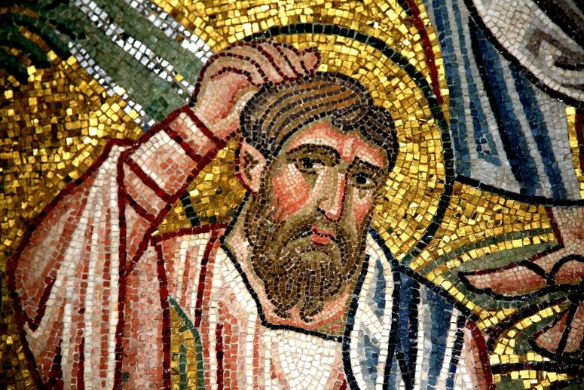
10.00 Morning Prayer at Mawnan, St Michael
Readings
Psalm 126
Acts 11.27—12.2 - David
Matthew 20.20–28 - Jenny
Intercessions - Catherine
Hymns
88. Brother, sister let me serve you
352. Jesus is Lord! Creation's voice proclaims it
281. He who would valiant be

11.15 Communion at Ponsanooth

This week’s Readings and Prayers
Collect
Merciful God,
whose holy apostle Saint James,
leaving his father and all that he had,
was obedient to the calling of your Son Jesus Christ
and followed him even to death:
help us, forsaking the false attractions of the world,
to be ready at all times to answer your call without delay;
through Jesus Christ your Son our Lord,
who is alive and reigns with you,
in the unity of the Holy Spirit,
one God, now and for ever.

Jeremiah 45.1–5
45 The word that the prophet Jeremiah spoke to Baruch son of Neriah, when he wrote these words in a scroll at the dictation of Jeremiah, in the fourth year of King Jehoiakim son of Josiah of Judah: ² Thus says the Lord, the God of Israel, to you, O Baruch: ³ You said, ‘Woe is me! The Lord has added sorrow to my pain; I am weary with my groaning, and I find no rest.’ ⁴ Thus you shall say to him, ‘Thus says the Lord: I am going to break down what I have built, and pluck up what I have planted—that is, the whole land. ⁵ And you, do you seek great things for yourself? Do not seek them; for I am going to bring disaster upon all flesh, says the Lord; but I will give you your life as a prize of war in every place to which you may go.’

Acts 11.27—12.2
²⁷ At that time prophets came down from Jerusalem to Antioch. ²⁸ One of them named Agabus stood up and predicted by the Spirit that there would be a severe famine over all the world; and this took place during the reign of Claudius. ²⁹ The disciples determined that according to their ability, each would send relief to the believers living in Judea; ³⁰ this they did, sending it to the elders by Barnabas and Saul.
12 About that time King Herod laid violent hands upon some who belonged to the church. ² He had James, the brother of John, killed with the sword.

Psalm 126
1 When the Lord restored the fortunes of Zion, •
then were we like those who dream.
2 Then was our mouth filled with laughter •
and our tongue with songs of joy.
3 Then said they among the nations, •
‘The Lord has done great things for them.’
4 The Lord has indeed done great things for us, •
and therefore we rejoiced.
5 Restore again our fortunes, O Lord, •
as the river beds of the desert.
6 Those who sow in tears •
shall reap with songs of joy.
7 Those who go out weeping, bearing the seed, •
will come back with shouts of joy,
bearing their sheaves with them.

2 Corinthians 4.7–15
⁷ But we have this treasure in clay jars, so that it may be made clear that this extraordinary power belongs to God and does not come from us. ⁸ We are afflicted in every way, but not crushed; perplexed, but not driven to despair; ⁹ persecuted, but not forsaken; struck down, but not destroyed; ¹⁰ always carrying in the body the death of Jesus, so that the life of Jesus may also be made visible in our bodies. ¹¹ For while we live, we are always being given up to death for Jesus’ sake, so that the life of Jesus may be made visible in our mortal flesh. ¹² So death is at work in us, but life in you.
¹³ But just as we have the same spirit of faith that is in accordance with scripture—‘I believed, and so I spoke’—we also believe, and so we speak, ¹⁴ because we know that the one who raised the Lord Jesus will raise us also with Jesus, and will bring us with you into his presence. ¹⁵ Yes, everything is for your sake, so that grace, as it extends to more and more people, may increase thanksgiving, to the glory of God.

Matthew 20.20–28
²⁰ Then the mother of the sons of Zebedee came to him with her sons, and kneeling before him, she asked a favour of him. ²¹ And he said to her, ‘What do you want?’ She said to him, ‘Declare that these two sons of mine will sit, one at your right hand and one at your left, in your kingdom.’ ²² But Jesus answered, ‘You do not know what you are asking. Are you able to drink the cup that I am about to drink?’ They said to him, ‘We are able.’ ²³ He said to them, ‘You will indeed drink my cup, but to sit at my right hand and at my left, this is not mine to grant, but it is for those for whom it has been prepared by my Father.’
²⁴ When the ten heard it, they were angry with the two brothers. ²⁵ But Jesus called them to him and said, ‘You know that the rulers of the Gentiles lord it over them, and their great ones are tyrants over them. ²⁶ It will not be so among you; but whoever wishes to be great among you must be your servant, ²⁷ and whoever wishes to be first among you must be your slave; ²⁸ just as the Son of Man came not to be served but to serve, and to give his life a ransom for many.’

Post Communion
Lord God, the source of truth and love,
keep us faithful to the apostles’ teaching and fellowship,
united in prayer and the breaking of bread,
and one in joy and simplicity of heart,
in Jesus Christ our Lord.

For our Prayers: Ponsanooth & Mawnan
Jeanette Edwards, Caroline Yannaghas, Val Ackland, Paul Bryer, Nick Bailey, Shirley Banks, Sylvia Weatherhead, Emma Chesshire, Sarah, Dennis and Louise Gartside, Ann Benney snr, Hazel Dobson, Toni Thomas, Arthur and Brenda Rule, Father Steve following his retirement, and others known to us who especially need our prayers.
We remember those who have died including Michael Martin, and we pray for all who mourn.
Our schools, and everyone on holiday.
The NHS, key workers, and our leaders.
Saltren and Charlotte, and Samantha and Richard, whose Banns we are reading this month.
Freddie Regini-Cook, being Baptised on 1 August.

Notices
Food Bank: This week’s needs: Meat soups, Wet cat food, Tinned potatoes, Tinned carrots, Coffee’ Tea bags (not loose tea), Baby wipes, Shaving foam, Sweets, Shower gel, Washing tablets, Toilet rolls, Long life milk. NOT CURRENTLY NEEDED: Pasta, Baked beans, pulses.
Cleaning: help still needed at St Mawnan

