New Covid Rules From 19 July, we recommend that we continue to wear facemasks, use sanitiser, and register with the Test and Trace system. Communion will be offered in one kind (the wafer) only and brought to you in your seat. We will share the peace with a wave. The area at the back of Church is to only be used by those who are strictly wearing masks, maintaining social distancing, and not singing.

Next week:
Wednesday 11 August
10.00 Celtic Morning Prayer at Mawnan, St Michael

Sunday 15 August 2021
11th Sunday after Trinity - True Bread
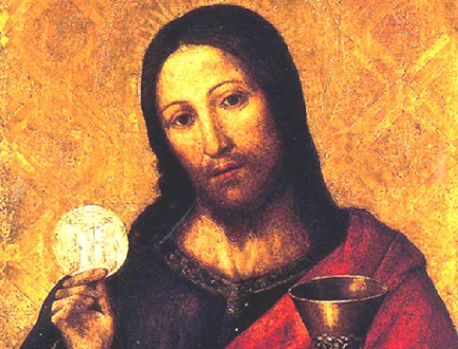
10.00 Communion at St Mawnan
Readings
Proverbs 9.1–6 - Catherine
Ephesians 5.15–20 - David
John 6.51–58
Intercessions - John
Hymns
58 Awake my soul
70 Be thou my vision
408 Lord enthroned
37 Angel voices

11.15 Morning Worship at Ponsanooth
Readings
Psalm 34.9–14
Proverbs 9.1–6
John 6.51–58
Rev Johanna Clare
(working days Tuesday, Wednesday, Thursday)
rev.johanna.clare@gmail.com - 07919 186307
St Mawnan, Church Road, TR11 5HY
Mawnan, St Michael, Carwinion Road, TR11 5JG
Ponsanooth, St Michael and All Angels,
St Michael’s Road, TR3 7ES
Website: stmawnan.org
Facebook: St Mawnan and St Michael

Mawnan & Ponsanooth
Sunday 8 August 2021
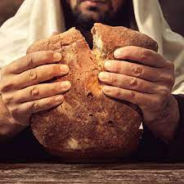
10th Sunday after Trinity - Bread of Life

8.00 BCP Communion at St Michael, Mawnan
Collect and Readings p172

10.00 Morning Prayer at St Michael, Mawnan
Readings
Psalm 34.1–8
1 Kings 19.4–8 - Sylvia
John 6.35, 41–51 - Ian
Intercessions - Libby
Hymns
12. Alleluia sing to Jesus
401. Listen let your heart keep seeking
252. Guide me O thou great redeemer

11.15 Communion at Ponsanooth
1 Kings 19.4–8
Ephesians 4.25—5.2
John 6.35, 41–51

This week’s Readings and Prayers
Collect
Lord of heaven and earth,
as Jesus taught his disciples to be persistent in prayer,
give us patience and courage never to lose hope,
but always to bring our prayers before you;
through Jesus Christ our Lord.
1 Kings 19.4–8
⁴ But he himself went a day’s journey into the wilderness, and came and sat down under a solitary broom tree. He asked that he might die: ‘It is enough; now, O Lord, take away my life, for I am no better than my ancestors.’ ⁵ Then he lay down under the broom tree and fell asleep. Suddenly an angel touched him and said to him, ‘Get up and eat.’ ⁶ He looked, and there at his head was a cake baked on hot stones, and a jar of water. He ate and drank, and lay down again. ⁷ The angel of the Lord came a second time, touched him, and said, ‘Get up and eat, otherwise the journey will be too much for you.’ ⁸ He got up, and ate and drank; then he went in the strength of that food for forty days and forty nights to Horeb the mount of God.

Psalm 34.1–8
1 I will bless the Lord at all times; •
his praise shall ever be in my mouth.
2 My soul shall glory in the Lord; •
let the humble hear and be glad.
3 O magnify the Lord with me; •
let us exalt his name together.
4 I sought the Lord and he answered me •
and delivered me from all my fears.
5 Look upon him and be radiant •
and your faces shall not be ashamed.
6 This poor soul cried, and the Lord heard me •
and saved me from all my troubles.
7 The angel of the Lord encamps around those who fear him •
and delivers them.
8 O taste and see that the Lord is gracious; •
blessed is the one who trusts in him.

Ephesians 4.25—5.2
²⁵ So then, putting away falsehood, let all of us speak the truth to our neighbours, for we are members of one another. ²⁶ Be angry but do not sin; do not let the sun go down on your anger, ²⁷ and do not make room for the devil. ²⁸ Thieves must give up stealing; rather let them labour and work honestly with their own hands, so as to have something to share with the needy. ²⁹ Let no evil talk come out of your mouths, but only what is useful for building up, as there is need, so that your words may give grace to those who hear. ³⁰ And do not grieve the Holy Spirit of God, with which you were marked with a seal for the day of redemption. ³¹ Put away from you all bitterness and wrath and anger and wrangling and slander, together with all malice, ³² and be kind to one another, tender-hearted, forgiving one another, as God in Christ has forgiven you. 5¹ Therefore be imitators of God, as beloved children, ² and live in love, as Christ loved us and gave himself up for us, a fragrant offering and sacrifice to God.

John 6.35, 41–51
³⁵ Jesus said to them, ‘I am the bread of life. Whoever comes to me will never be hungry, and whoever believes in me will never be thirsty.
⁴¹ Then the Jews began to complain about him because he said, ‘I am the bread that came down from heaven.’ ⁴² They were saying, ‘Is not this Jesus, the son of Joseph, whose father and mother we know? How can he now say, “I have come down from heaven”?’ ⁴³ Jesus answered them, ‘Do not complain among yourselves. ⁴⁴ No one can come to me unless drawn by the Father who sent me; and I will raise that person up on the last day. ⁴⁵ It is written in the prophets, “And they shall all be taught by God.” Everyone who has heard and learned from the Father comes to me. ⁴⁶ Not that anyone has seen the Father except the one who is from God; he has seen the Father. ⁴⁷ Very truly, I tell you, whoever believes has eternal life. ⁴⁸ I am the bread of life. ⁴⁹ Your ancestors ate the manna in the wilderness, and they died. ⁵⁰ This is the bread that comes down from heaven, so that one may eat of it and not die. ⁵¹ I am the living bread that came down from heaven. Whoever eats of this bread will live for ever; and the bread that I will give for the life of the world is my flesh.’
Post Communion
God of our pilgrimage,
you have willed that the gate of mercy
should stand open for those who trust in you:
look upon us with your favour
that we who follow the path of your will
may never wander from the way of life;
through Jesus Christ our Lord.

For our Prayers: Ponsanooth & Mawnan
Franziska Spindler, Robert Thompson, Jeanette Edwards, Caroline Yannaghas, Val Ackland, Paul Bryer, Nick Bailey, Shirley Banks, Sylvia Weatherhead, Emma Chesshire, Sarah, Dennis and Louise Gartside, Ann Benney snr, Hazel Dobson, Toni Thomas, Arthur and Brenda Rule, Father Steve following his retirement, and others known to us who especially need our prayers.
We remember those who have died including Christine Norcott, Brain Philpotts and Michael Martin, and we pray for all who mourn.
Our schools, and everyone on holiday.
The NHS, key workers, and our leaders.
Saltren and Charlotte, and Samantha and Richard, whose weddings are this month.

Notices
Food Bank: This week’s needs: Fruit squash, Shaving foam, Shower gel, Washing tablets, Toilet rolls, Tinned meat, Baby wipes, Coffee, Tinned carrots, Cereal, Size 5 nappies, Sweets. CURRENTLY NOT NEEDED: Baked beans, Pasta, Pulses, Loose tea

