For Our Prayers continued:
Afghanistan and Haiti, and for Climate justice.
We remember those who have died including Stuart Annan andChristine Smales and we pray for all who mourn.
Sophie & Eddie whose wedding is on 2 October
Oscar Samuel whose Baptism is on 3 October

Notices
The Food Bank is very short of Bags for Life and carrier bags at the moment. They also need Tinned Meatballs, Long Life Milk, Tinned Custard, Tinned Rice Pudding, Small Jars of Coffee, Tinned Tomatoes, Cup-a-Soups, Fruit Squash, Toothpaste, Toilet Rolls, Shower Gel, Deodorant, Shaving Foam.

Next week:
Wednesday 29 September
10.00 BCP Communion at Mawnan, St Michael
19.00 LYCiG via Zoom

Sunday 3 October 2021
18th Sunday after Trinity - Happy Families
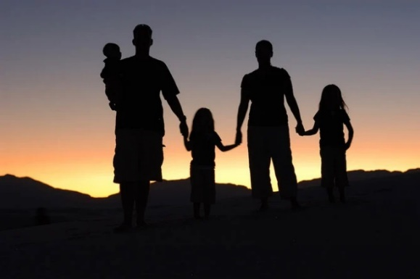
10.00 Communion at St Mawnan
Readings
Genesis 2.18–24 -Caroline
Hebrews 1.1–4, 2.5–12 - Ian
Mark 10.2–16
Intercessions - Libby
Hymns
359 Jesus shall reign
718 We love the place
54 At the name of Jesus
511 O Lord my God

10.45 Methodist Service in the Café at Ponsanooth Hall
Rev Johanna Clare
(working days Tuesday, Wednesday, Thursday)
rev.johanna.clare@gmail.com - 07919 186307
St Mawnan, Church Road, TR11 5HY
Mawnan, St Michael, Carwinion Road, TR11 5JG
Ponsanooth, St Michael and All Angels,
St Michael’s Road, TR3 7ES

stmawnan.org St Mawnan and St Michael
Mawnan & Ponsanooth
Sunday 26 September 2021
Michael and All Angels

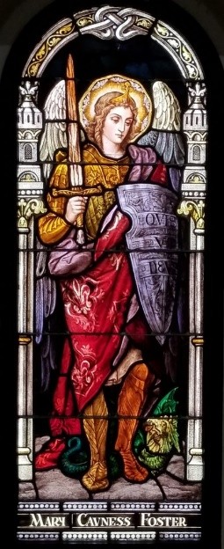
10.00 Morning Prayer at St Michael, Mawnan
Readings
Psalm 103.19-end
Genesis 28.10–17 – Jenny
Revelation 12.7-12- David
John 1.47-end
Intercessions - Catherine

11.15 Communion at Ponsanooth
Genesis 28.10–17
Revelation 12.7-12
John 1.47-end

Hymns
570 (425). Praise the Lord ye heavens adore him
(see below) Lord God, to Thee we give all praise
775 (36). As Jacob with travel was weary one day
758 (567). Ye watchers and ye holy ones [Omit v2]
Lord God, to Thee we give all praise,
With grateful hearts our voices raise,
That angel hosts Thou didst create
Around Thy glorious throne to wait.
They shine with light and heav'nly grace
And constantly behold Thy face;
They heed Thy voice, they know it well,
In godly wisdom they excel.
They never rest nor sleep as we;
Their whole delight is but to be
With Thee, Lord Jesus, and to keep
Thy little flock, Thy lambs and sheep.
The ancient dragon is their foe;
His envy and his wrath they know.
It always is his aim and pride
Thy Christian people to divide.
But watchful is the angel band
That follows Christ on ev'ry hand
To guard His people where they go
And break the counsel of the foe.
For this, now and in days to be,
Our praise shall rise, O Lord, to Thee,
Whom all the angel hosts adore
With grateful songs forevermore.
This week’s Readings and Prayers
Collect
Everlasting God,
you have ordained and constituted the ministries of angels and mortals in a wonderful order:
grant that as your holy angels always serve you in heaven,
so, at your command,
they may help and defend us on earth;
through Jesus Christ your Son our Lord,
who is alive and reigns with you,
in the unity of the Holy Spirit,
one God, now and for ever.

Psalm 103.19-end
19 The Lord has established his throne in heaven, •
and his kingdom has dominion over all.
20 Bless the Lord, you angels of his, •
you mighty ones who do his bidding
and hearken to the voice of his word.
21 Bless the Lord, all you his hosts, •
you ministers of his who do his will.
22 Bless the Lord, all you works of his,
in all places of his dominion; •
bless the Lord, O my soul.

Genesis 28.10–17
Jacob’s Dream at Bethel
10 Jacob left Beer-sheba and went towards Haran. ¹¹He came to a certain place and stayed there for the night, because the sun had set. Taking one of the stones of the place, he put it under his head and lay down in that place. ¹²And he dreamed that there was a ladder* set up on the earth, the top of it reaching to heaven; and the angels of God were ascending and descending on it. ¹³And the Lord stood beside him* and said, ‘I am the Lord, the God of Abraham your father and the God of Isaac; the land on which you lie I will give to you and to your offspring; ¹⁴and your offspring shall be like the dust of the earth, and you shall spread abroad to the west and to the east and to the north and to the south; and all the families of the earth shall be blessed* in you and in your offspring. ¹⁵Know that I am with you and will keep you wherever you go, and will bring you back to this land; for I will not leave you until I have done what I have promised you.’ ¹⁶Then Jacob woke from his sleep and said, ‘Surely the Lord is in this place—and I did not know it!’ ¹⁷And he was afraid, and said, ‘How awesome is this place! This is none other than the house of God, and this is the gate of heaven.’

Revelation 12.7-12
Michael Defeats the Dragon
7 And war broke out in heaven; Michael and his angels fought against the dragon. The dragon and his angels fought back, ⁸but they were defeated, and there was no longer any place for them in heaven. ⁹The great dragon was thrown down, that ancient serpent, who is called the Devil and Satan, the deceiver of the whole world—he was thrown down to the earth, and his angels were thrown down with him.
10 Then I heard a loud voice in heaven, proclaiming,
‘Now have come the salvation and the power
and the kingdom of our God
and the authority of his Messiah,*
for the accuser of our comrades* has been thrown down,
who accuses them day and night before our God.
¹¹ But they have conquered him by the blood of the Lamb
and by the word of their testimony,
for they did not cling to life even in the face of death.
¹² Rejoice then, you heavens
and those who dwell in them!
But woe to the earth and the sea,
for the devil has come down to you
with great wrath,
because he knows that his time is short!’

John 1.47-end
When Jesus saw Nathanael coming towards him, he said of him, ‘Here is truly an Israelite in whom there is no deceit!’ Nathanael asked him, ‘Where did you come to know me?’ Jesus answered, ‘I saw you under the fig tree before Philip called you.’ Nathanael replied, ‘Rabbi, you are the Son of God! You are the King of Israel!’ Jesus answered, ‘Do you believe because I told you that I saw you under the fig tree? You will see greater things than these.’ And he said to him, ‘Very truly, I tell you, you will see heaven opened and the angels of God ascending and descending upon the Son of Man.’

Post Communion Prayer
Lord of heaven,
in this eucharist you have brought us near to an innumerable company of angels
and to the spirits of the saints made perfect:
as in this food of our earthly pilgrimage we have shared their fellowship,
so may we come to share their joy in heaven;
through Jesus Christ our Lord.

For our Prayers: Ponsanooth & Mawnan
Margaret Lugg and family, Catherine Smith, Merle Jenkins, Carolyn Brodie, Franziska Spindler, Robert Thompson, Jeanette Edwards, Caroline Yannaghas, Val Ackland, Paul Bryer, Shirley Banks, Sarah, Emma Chesshire, Dennis and Louise Gartside, Ann Benney snr, David Charles, Hazel Dobson, Toni Thomas, Arthur and Brenda Rule, and others known to us who especially need our prayers.
Our schools preparing for Harvest.

