Mawnan School Governors: This rewarding role requires time, professional skills, energy and commitment. Please speak to Johanna if you know someone who might be suitable.
Falmouth Live Nativity: - Sunday 5th December, but this involves a large team of organisers. There are many roles to fill. Please speak to Johanna for details.

Mothers’ Union Meeting: Wednesday 8th September at 2.30 in Mawnan Memorial Hall

Next week:
Wednesday 8 September
10.00 Celtic Prayers at Mawnan, St Michael
Thursday 9 September
19.30 Mabe and Ponsanooth PCC at St Laudus

Sunday 12 September 2021
15th Sunday after Trinity
Who do you say that I am?

8.00 BCP Communion at St Michael, Mawnan
Collect and Readings p180

10.00 Morning Prayer at St Michael, Mawnan
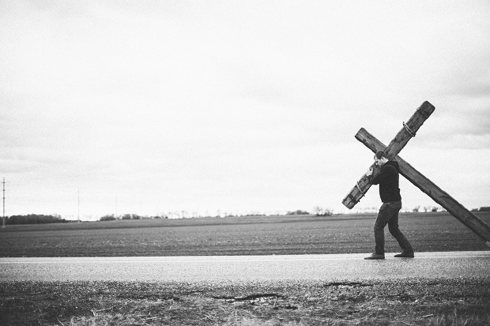
Readings
Psalm 116.1–8
Isaiah 50.4–9a David
Mark 8.27–end - Catherine
Intercessions - Libby
Hymns
573. Praise to the Lord the Almighty
247. Great indeed are your works O Lord
355. Jesus name above all names
752. Will you come and follow me

11.15 Communion at Ponsanooth
Isaiah 50.4–9a
James 3.1–12
Mark 8.27–end

Rev Johanna Clare
(working days Tuesday, Wednesday, Thursday)
rev.johanna.clare@gmail.com - 07919 186307
St Mawnan, Church Road, TR11 5HY
Mawnan, St Michael, Carwinion Road, TR11 5JG
Ponsanooth, St Michael and All Angels,
St Michael’s Road, TR3 7ES

stmawnan.org St Mawnan and St Michael
Mawnan & Ponsanooth
Sunday 5 September 2021
14th Sunday after Trinity - Even the dogs
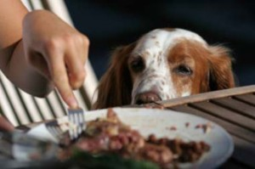
10.00 Communion at St Mawnan
Readings
Isaiah 35.4–7a - Ian
James 2.1–17 - Caroline
Mark 7.24–end
Intercessions - Johanna
Hymns
21 All people that on earth
67 Be still for the presence
29 Amazing grace
684 Thou whose almighty word

10.45 Methodist Service in the Café at Ponsanooth Hall

This week’s Readings and Prayers
Collect
Merciful God,
your Son came to save us
and bore our sins on the cross:
may we trust in your mercy
and know your love,
rejoicing in the righteousness
that is ours through Jesus Christ our Lord.
Isaiah 35.4–7a
⁴ Say to those who are of a fearful heart,
‘Be strong, do not fear!
Here is your God.
He will come with vengeance,
with terrible recompense.
He will come and save you.’
⁵ Then the eyes of the blind shall be opened,
and the ears of the deaf unstopped;
⁶ then the lame shall leap like a deer,
and the tongue of the speechless sing for joy.
For waters shall break forth in the wilderness,
and streams in the desert;
⁷ the burning sand shall become a pool,
and the thirsty ground springs of water;
the haunt of jackals shall become a swamp,
the grass shall become reeds and rushes.

James 2.1–17
2 My brothers and sisters, do you with your acts of favouritism really believe in our glorious Lord Jesus Christ? ² For if a person with gold rings and in fine clothes comes into your assembly, and if a poor person in dirty clothes also comes in, ³ and if you take notice of the one wearing the fine clothes and say, ‘Have a seat here, please’, while to the one who is poor you say, ‘Stand there’, or, ‘Sit at my feet’, ⁴ have you not made distinctions among yourselves, and become judges with evil thoughts? ⁵ Listen, my beloved brothers and sisters. Has not God chosen the poor in the world to be rich in faith and to be heirs of the kingdom that he has promised to those who love him? ⁶ But you have dishonoured the poor. Is it not the rich who oppress you? Is it not they who drag you into court? ⁷ Is it not they who blaspheme the excellent name that was invoked over you?
⁸ You do well if you really fulfil the royal law according to the scripture, ‘You shall love your neighbour as yourself.’ ⁹ But if you show partiality, you commit sin and are convicted by the law as transgressors. ¹⁰ For whoever keeps the whole law but fails in one point has become accountable for all of it. ¹¹ For the one who said, ‘You shall not commit adultery’, also said, ‘You shall not murder.’ Now if you do not commit adultery but if you murder, you have become a transgressor of the law. ¹² So speak and so act as those who are to be judged by the law of liberty. ¹³ For judgement will be without mercy to anyone who has shown no mercy; mercy triumphs over judgement.
¹⁴ What good is it, my brothers and sisters, if you say you have faith but do not have works? Can faith save you? ¹⁵ If a brother or sister is naked and lacks daily food, ¹⁶ and one of you says to them, ‘Go in peace; keep warm and eat your fill’, and yet you do not supply their bodily needs, what is the good of that? ¹⁷ So faith by itself, if it has no works, is dead.

Mark 7.24–end
²⁴ From there he set out and went away to the region of Tyre. He entered a house and did not want anyone to know he was there. Yet he could not escape notice, ²⁵ but a woman whose little daughter had an unclean spirit immediately heard about him, and she came and bowed down at his feet. ²⁶ Now the woman was a Gentile, of Syrophoenician origin. She begged him to cast the demon out of her daughter. ²⁷ He said to her, ‘Let the children be fed first, for it is not fair to take the children’s food and throw it to the dogs.’ ²⁸ But she answered him, ‘Sir, even the dogs under the table eat the children’s crumbs.’ ²⁹ Then he said to her, ‘For saying that, you may go—the demon has left your daughter.’ ³⁰ So she went home, found the child lying on the bed, and the demon gone.
³¹ Then he returned from the region of Tyre, and went by way of Sidon towards the Sea of Galilee, in the region of the Decapolis. ³² They brought to him a deaf man who had an impediment in his speech; and they begged him to lay his hand on him. ³³ He took him aside in private, away from the crowd, and put his fingers into his ears, and he spat and touched his tongue. ³⁴ Then looking up to heaven, he sighed and said to him, ‘Ephphatha’, that is, ‘Be opened.’ ³⁵ And immediately his ears were opened, his tongue was released, and he spoke plainly. ³⁶ Then Jesus ordered them to tell no one; but the more he ordered them, the more zealously they proclaimed it. ³⁷ They were astounded beyond measure, saying, ‘He has done everything well; he even makes the deaf to hear and the mute to speak.’
Post Communion
Lord God, the source of truth and love,
keep us faithful to the apostles’ teaching and fellowship,
united in prayer and the breaking of bread,
and one in joy and simplicity of heart,
in Jesus Christ our Lord.

For our Prayers: Ponsanooth & Mawnan
Merle Jenkins, Christine Smales, Carolyn Brodie, Zara Mitchell, Franziska Spindler, Robert Thompson, Jeanette Edwards, Caroline Yannaghas, Val Ackland, Paul Bryer, Shirley Banks, Sylvia Weatherhead, Sarah, Emma Chesshire, Dennis and Louise Gartside, Ann Benney snr, David Charles, Hazel Dobson, Toni Thomas, Arthur and Brenda Rule, and others known to us who especially need our prayers.
We remember those who have died including Christine Sarl, Jilly, Christine Norcott, Brian Philpotts and Michael Martin, and we pray for all who mourn.
Our schools, and everyone on holiday.
Afghanistan and Haiti.
Climate justice.
Sophie & Eddie, and Alan & Alexandra, whose Banns we are reading this month .

Notices

Open-Air Service: On Sunday 19 September we will be having an open-air service at St Mawnan celebrating Creation. This is to tie in with the Big Green Week. We will have some photos from the WI competition on show in Church. There will be a nature trail around the Churchyard. Bring a picnic for lunch. And a chair or a rug. And a friend or two.

