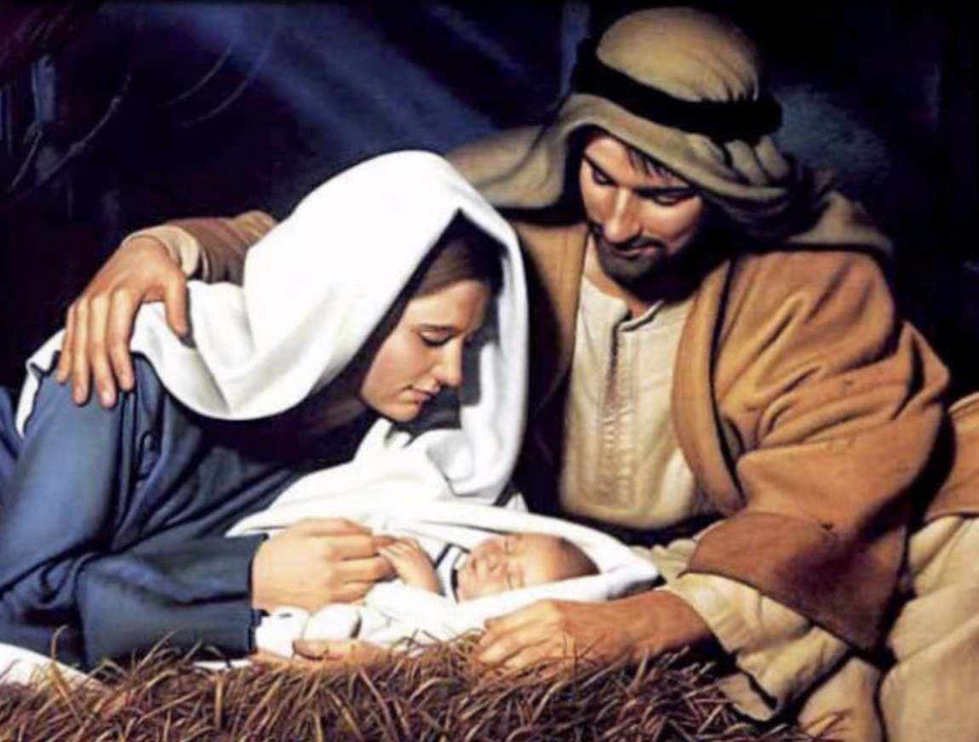
Christmas Services
At Mawnan:
Sunday 12 December
10am Lessons and Carols at St Michael
Wednesday 15 December
10am Celtic Christmas at St Michael
Friday 24 December
5pm Candlelit Christmas & Carols at St Mawnan
Saturday 25 December
10am Family Christmas Communion at St Michael
At SM&AA, Ponsanooth:
Thursday 16 December
7pm Carol Service
Saturday 25 December
11.15am Christmas Communion

Next week:
Wednesday 24 November
10.00 Celtic Morning Prayer at Mawnan, St Michael

Sunday 28 November 2021

1st Sunday of Advent
10.00 Morning Prayer at St Michael, Mawnan
Readings
Psalm 25.1–9
Jeremiah 33.14–16 - Jenny
Luke 21.25–36 - Sylvia
Intercessions - Catherine
Hymns
263 Hark, a thrilling voice
655 The lord will come
282 Hills of the north
405 Lo! He comes

11.15 Communion at Ponsanooth
Jeremiah 33.14–16
1 Thessalonians 3.9–end
Luke 21.25–36
Rev Johanna Clare
(working days Tuesday, Wednesday, Thursday)
rev.johanna.clare@gmail.com - 07919 186307
St Mawnan, Church Road, TR11 5HY
Mawnan, St Michael, Carwinion Road, TR11 5JG
Ponsanooth, St Michael and All Angels,
St Michael’s Road, TR3 7ES

stmawnan.org St Mawnan and St Michael
Mawnan & Ponsanooth
Sunday 21 November 2021
Sunday next before Advent
Christ the King
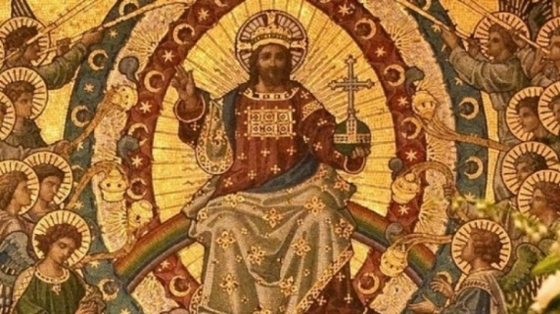
10.00 Communion at St Mawnan
Readings
Daniel 7.9–10, 13, 14 - David
Revelation 1.4b–8 - John
John 18.33–37
Intercessions – Libby
Hymns
382 Let all the world
649 The king of love
580 Rejoice the lord is king
644 The head that once

10.45 Methodist Service in the Café at Ponsanooth Hall

This week’s Readings and Prayers
Collect
God the Father,
help us to hear the call of Christ the King
and to follow in his service,
whose kingdom has no end;
for he reigns with you and the Holy Spirit,
one God, one glory.

Daniel 7.9–10, 13, 14
Judgement before the Ancient One
⁹ As I watched,
thrones were set in place,
and an Ancient One took his throne;
his clothing was white as snow,
and the hair of his head like pure wool;
his throne was fiery flames,
and its wheels were burning fire.
¹⁰ A stream of fire issued
and flowed out from his presence.
A thousand thousand served him,
and ten thousand times ten thousand stood attending him.
The court sat in judgement,
and the books were opened.
¹³As I watched in the night visions,
I saw one like a human being
coming with the clouds of heaven.
And he came to the Ancient One
and was presented before him.
¹⁴ To him was given dominion
and glory and kingship,
that all peoples, nations, and languages
should serve him.
His dominion is an everlasting dominion
that shall not pass away,
and his kingship is one
that shall never be destroyed.

Revelation 1.4b–8
⁴ John to the seven churches that are in Asia:
Grace to you and peace from him who is and who was and who is to come, and from the seven spirits who are before his throne, ⁵ and from Jesus Christ, the faithful witness, the firstborn of the dead, and the ruler of the kings of the earth.
To him who loves us and freed us from our sins by his blood, ⁶ and made us to be a kingdom, priests serving his God and Father, to him be glory and dominion for ever and ever. Amen.
⁷ Look! He is coming with the clouds;
every eye will see him,
even those who pierced him;
and on his account all the tribes of the earth will wail.
So it is to be. Amen.
⁸ ‘I am the Alpha and the Omega’, says the Lord God, who is and who was and who is to come, the Almighty.

John 18.33–37
³³ Then Pilate entered the headquarters again, summoned Jesus, and asked him, ‘Are you the King of the Jews?’ ³⁴ Jesus answered, ‘Do you ask this on your own, or did others tell you about me?’ ³⁵ Pilate replied, ‘I am not a Jew, am I? Your own nation and the chief priests have handed you over to me. What have you done?’ ³⁶ Jesus answered, ‘My kingdom is not from this world. If my kingdom were from this world, my followers would be fighting to keep me from being handed over to the Jews. But as it is, my kingdom is not from here.’ ³⁷ Pilate asked him, ‘So you are a king?’ Jesus answered, ‘You say that I am a king. For this I was born, and for this I came into the world, to testify to the truth. Everyone who belongs to the truth listens to my voice.’

Post Communion
Stir up, O Lord,
the wills of your faithful people;
that they, plenteously bringing forth the fruit of good works,
may by you be plenteously rewarded;
through Jesus Christ our Lord.
For our Prayers: Ponsanooth & Mawnan
Maple, Mel Jenkins, Ann Barnes, Cecil Birch, Margaret Lugg and family, Catherine Smith, Carolyn Brodie, Franziska Spindler, Robert Thompson, Jeanette Edwards, Caroline Yannaghas, Val Ackland, Paul Bryer, Shirley Banks, Sarah, Emma Chesshire, Dennis and Louise Gartside, Ann Benney snr, David Charles, Hazel Dobson, Toni Thomas, Arthur and Brenda Rule, and others known to us who especially need our prayers.
We remember those who have died including Helen Chevis, Geoffrey Cook, Merle Jenkins, Allen Stevens and Colin Ford, and we pray for all who mourn.
For Laura and Preston whose Banns we are reading this month
For our wonderful school community

Notices:
Mawnan Church Coffee Morning Saturday 11 December, 10.00-12.00 in the Memorial Hall. There will be tea, coffee, mince pies, cakes, Christmas goodies and a raffle. Ian would be very grateful for offers of baked goods and contributions for a hamper. Thank you.

Cornwall Christmas Box: We are aiming to donate two boxes from Mawnan Churches to this appeal.
There is a box at the back of each church with a list of what’s required. If you would like to contribute, please tick the item and write your name beside it. (We don’t want to have 20 boxes of stuffing and no mince pies!!) We need the items by Sunday 5th December, so that the boxes can be assembled and delivered to The Red Lion by Friday 10th.

Stanley’s Steps for Children in Need:
The Amazing Stanley Barnes and his
team of helpers at Mawnan School
walked 10 miles in five days last week.
You can make a donation at www.justgiving.com/fundraiing/h-martin5

Change to Wednesday services. The usual pattern of our Wednesday morning 10am services is changing to:
1st Wednesday of each month BCP Communion
2nd, 3rd, 4th & 5th Celtic Morning Prayer

The Penryn and Falmouth Foodbank urgently needs: Toilet Rolls, Washing Powder/Tablets, Tinned Pasta Meals, Tinned Spaghetti, Fruit Squash/Juice, Tea Bags, Tinned Potatoes, Instant Mashed Potatoes, Long Life Milk, Alternative Milks - Oat/Soya/Coconut, Breakfast Cereal, Savoury Snacks, Tinned Meat Meals

The MU coffee morning raised £280 for the Truro Refuges. Well done to everyone involved.

