Next week:
Wednesday 10 November
10.00 Celtic Prayers at Mawnan, St Michael
10.30 Cleaning at St Mawnan
2.30 Allen Stevens funeral at St Mawnan
Thursday 11 November
10.50 Act of Remembrance Day at Mawnan Memorial Hall
Saturday 13 November
9.30-3.00 On the Way Day at the Penmorvah Manor Hotel

Sunday 14 November 2021
2nd Sunday before Advent

8.00 BCP Communion at St Michael, Mawnan
Collect and Readings p195

10.30 Remembrance Sunday Service at St Mawnan
Readings
Daniel 12.1–3
Hebrews 10.11–14, 19–25
Mark 13.1–8

10.45 Remembrance Sunday Service at SM& AA Ponsanooth
Readings
Daniel 12.1–3
Hebrews 10.11–14, 19–25
Mark 13.1–8
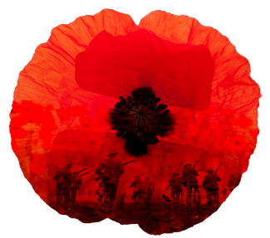

Rev Johanna Clare
(working days Tuesday, Wednesday, Thursday)
rev.johanna.clare@gmail.com - 07919 186307
St Mawnan, Church Road, TR11 5HY
Mawnan, St Michael, Carwinion Road, TR11 5JG
Ponsanooth, St Michael and All Angels,
St Michael’s Road, TR3 7ES

stmawnan.org St Mawnan and St Michael
Mawnan & Ponsanooth

Sunday 7 November 2021
3rd Sunday before Advent
Jonah

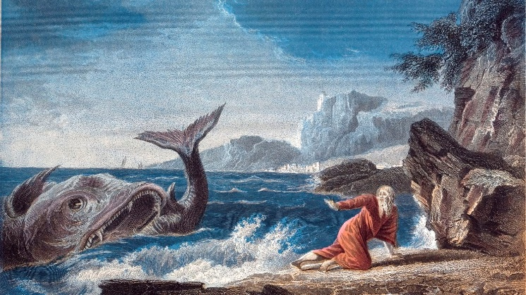

10.00 Communion at St Mawnan
Readings
Jonah 3.1–5, 10 - Caroline
Hebrews 9.24–end - Catherine
Mark 1.14–20
Intercessions - David
Hymns
32. And can it be
67. Be still for the presence of the Lord
752. Will you come and follow me
503. O Jesus I have promised

10.45 Methodist Service in the Café at Ponsanooth Hall

This week’s Readings and Prayers
Collect
God, our refuge and strength,
bring near the day when wars shall cease
and poverty and pain shall end,
that earth may know the peace of heaven
through Jesus Christ our Lord.
Jonah 3.1–5, 10
3 The word of the Lord came to Jonah a second time, saying, ² ‘Get up, go to Nineveh, that great city, and proclaim to it the message that I tell you.’ ³ So Jonah set out and went to Nineveh, according to the word of the Lord. Now Nineveh was an exceedingly large city, a three days’ walk across. ⁴ Jonah began to go into the city, going a day’s walk. And he cried out, ‘Forty days more, and Nineveh shall be overthrown!’ ⁵ And the people of Nineveh believed God; they proclaimed a fast, and everyone, great and small, put on sackcloth.
¹⁰ When God saw what they did, how they turned from their evil ways, God changed his mind about the calamity that he had said he would bring upon them; and he did not do it.

Hebrews 9.24–end
²⁴ For Christ did not enter a sanctuary made by human hands, a mere copy of the true one, but he entered into heaven itself, now to appear in the presence of God on our behalf. ²⁵ Nor was it to offer himself again and again, as the high priest enters the Holy Place year after year with blood that is not his own; ²⁶ for then he would have had to suffer again and again since the foundation of the world. But as it is, he has appeared once for all at the end of the age to remove sin by the sacrifice of himself. ²⁷ And just as it is appointed for mortals to die once, and after that the judgement, ²⁸ so Christ, having been offered once to bear the sins of many, will appear a second time, not to deal with sin, but to save those who are eagerly waiting for him.

Mark 1.14–20
¹⁴ Now after John was arrested, Jesus came to Galilee, proclaiming the good news of God, ¹⁵ and saying, ‘The time is fulfilled, and the kingdom of God has come near; repent, and believe in the good news.’
¹⁶ As Jesus passed along the Sea of Galilee, he saw Simon and his brother Andrew casting a net into the lake—for they were fishermen. ¹⁷ And Jesus said to them, ‘Follow me and I will make you fish for people.’ ¹⁸ And immediately they left their nets and followed him. ¹⁹ As he went a little farther, he saw James son of Zebedee and his brother John, who were in their boat mending the nets. ²⁰ Immediately he called them; and they left their father Zebedee in the boat with the hired men, and followed him.
Post Communion
God of peace,
whose Son Jesus Christ proclaimed the kingdom
and restored the broken to wholeness of life:
look with compassion on the anguish of the world,
and by your healing power
make whole both people and nations;
through our Lord and Saviour Jesus Christ.
For our Prayers: Ponsanooth & Mawnan
Ann Barnes, Cecil Birch, Margaret Lugg and family, Catherine Smith, Carolyn Brodie, Franziska Spindler, Robert Thompson, Jeanette Edwards, Caroline Yannaghas, Val Ackland, Paul Bryer, Shirley Banks, Sarah, Emma Chesshire, Dennis and Louise Gartside, Ann Benney snr, David Charles, Hazel Dobson, Toni Thomas, Arthur and Brenda Rule, and others known to us who especially need our prayers.
We remember those who have died including Merle Jenkins, Allen Stevens, Colin Ford, Stuart Annan and Christine Smales and we pray for all who mourn.
For the success of the COP26 talks.
For Laura and Preston whose Banns we are reading this month

Notices:
Falmouth & Penryn Churches Together PRAYERS FOR COP26 from Monday 1 November to Friday 12 November between 10.00am and noon in the Memorial Chapel at Falmouth Methodist Church. All Welcome

The Foodbank is preparing Christmas boxes for families using the foodbank over the festive season. They would welcome donations of the following tinned food: Ham, Meat Meals, Potatoes, Carrots, Green Vegetables, Sweetcorn, Custard, Fruit, Cream. They also need Gravy Granules, Stuffing, Cranberry Sauce, Christmas Pudding or Similar, Trifle Packs or Fruit Jelly, Mince Pies, Christmas Cake or Chocolate Log, Quality Biscuits, Box/Tin Chocolates, Savoury Snacks e.g. nuts and or crisps.
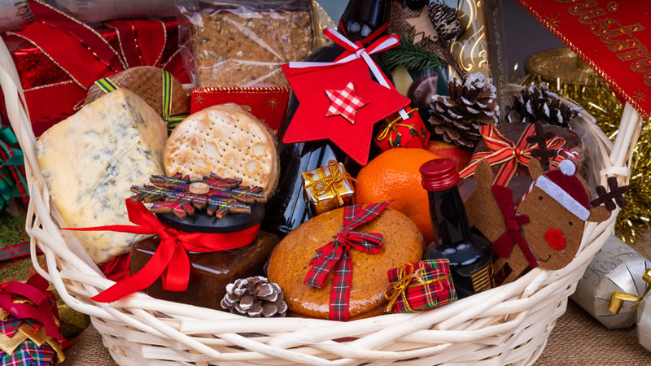
Mawnan Christmas Coffee Morning Saturday 11 December, 10.00-12.00 in the memorial Hall. Please let Ian know if you can help with Cakes, raffle prizes, or on the day. Thank you.

