Notices:
Masks: Following the changes to Covid rules, everyone who is over the age of 11, and not medically exempt, is required to wear a mask in Church. Please also continue to sanitise your hands on entering the building. Thank you.

Mothers’ Union AGM Wednesday 12th January at 2.30 pm in MMH, followed by a talk from Ellie Stacey about Falmouth and Penryn Welcoming Refugees.

Next week:
Wednesday 12 January
10.00 Celtic Worship at Mawnan, St Michael

Sunday 16 January 2022
2nd Sunday of Epiphany

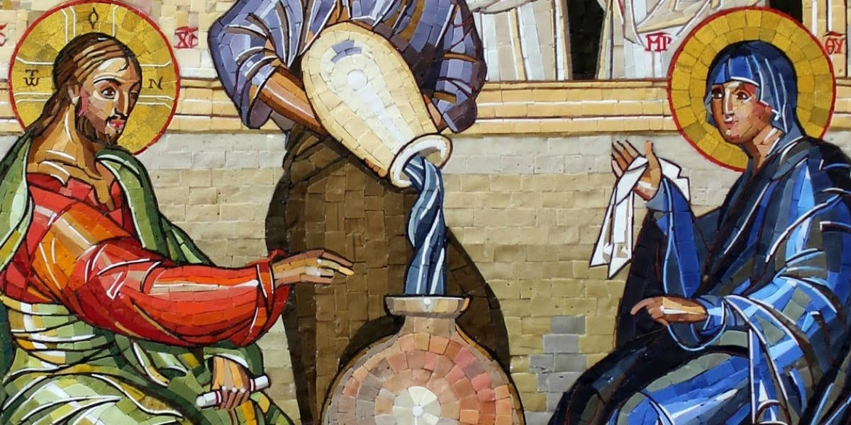

10.00 Communion at St Mawnan
Readings
Isaiah 62.1–5 - John
Corinthians 12.1–11 - Jenny
John 2.1–11
Intercessions – David
Hymns
304 I come with joy
580 Rejoice! The Lord is king!
163 Father, Lord of all creation
636 The Church’s one foundation

10.45 Methodist Service in the Café at Ponsanooth Hall

Rev Johanna Clare
(working days Tuesday, Wednesday, Thursday)
rev.johanna.clare@gmail.com - 07919 186307
St Mawnan, Church Road, TR11 5HY
Mawnan, St Michael, Carwinion Road, TR11 5JG
Ponsanooth, St Michael and All Angels,
St Michael’s Road, TR3 7ES

stmawnan.org St Mawnan and St Michael
Mawnan & Ponsanooth
Sunday 9 January 2022
Baptism of Christ

8.00 BCP Communion at St Michael, Mawnan
Collect and Readings p67

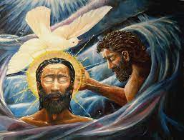
10.00 Morning Prayer at St Michael, Mawnan
Psalm 29
Isaiah 43.1–7 - David
Luke 3.15–17, 21–22 - Libby
Intercessions – John

42 Ascribe greatness
150 Do not be afraid for I have redeemed you
See below: Down by the Jordan
527 On Jordan's bank the Baptist's cry

Down by the Jordan,
a prophet named John was baptising,
Preaching a message
the people found bold and surprising:
"God will forgive! Show that you'll change how you live!
Surely God's new day is rising!"
There by the river,
the crowd came with great expectation:
"Are you God's Chosen One,
sent here to rescue our nation?"
"No!" John replied. "He who is mightier than I
Judges and offers salvation."
Jesus, you went to be baptised
along with the others,
Taking your place among sinners,
God's lost sons and daughters.
Then with great love, God's Spirit came as a dove!
Your work began in those waters.

Here in the Church,
we are baptised and filled with God's Spirit.
Freed and forgiven,
we're welcomed with joy! Can you hear it?
This is God's sign! This is how God says, "You're mine!"
Let's take the good news and share it!

11.15 Communion at Ponsanooth
Isaiah 43.1–7
Acts 8.14–17
Luke 3.15–17, 21–22
This week’s Readings and Prayers
Collect
Heavenly Father,
at the Jordan you revealed Jesus as your Son:
may we recognize him as our Lord
and know ourselves to be your beloved children;
through Jesus Christ our Saviour.

Isaiah 43.1–7
43 But now thus says the Lord,
he who created you, O Jacob,
he who formed you, O Israel:
Do not fear, for I have redeemed you;
I have called you by name, you are mine.
² When you pass through the waters, I will be with you;
and through the rivers, they shall not overwhelm you;
when you walk through fire you shall not be burned,
and the flame shall not consume you.
³ For I am the Lord your God,
the Holy One of Israel, your Saviour.
I give Egypt as your ransom,
Ethiopia and Seba in exchange for you.
⁴ Because you are precious in my sight,
and honoured, and I love you,
I give people in return for you,
nations in exchange for your life.
⁵ Do not fear, for I am with you;
I will bring your offspring from the east,
and from the west I will gather you;
⁶ I will say to the north, ‘Give them up’,
and to the south, ‘Do not withhold;
bring my sons from far away
and my daughters from the end of the earth—
⁷ everyone who is called by my name,
whom I created for my glory,
whom I formed and made.’

Psalm 29
1 Ascribe to the Lord, you powers of heaven, •
ascribe to the Lord glory and strength.
2 Ascribe to the Lord the honour due to his name; •
worship the Lord in the beauty of holiness.
3 The voice of the Lord is upon the waters;
the God of glory thunders; •
the Lord is upon the mighty waters.
4 The voice of the Lord is mighty in operation; •
the voice of the Lord is a glorious voice.
5 The voice of the Lord breaks the cedar trees; •
the Lord breaks the cedars of Lebanon;
6 He makes Lebanon skip like a calf •
and Sirion like a young wild ox.
7 The voice of the Lord splits the flash of lightning;
the voice of the Lord shakes the wilderness; •
the Lord shakes the wilderness of Kadesh.
8 The voice of the Lord makes the oak trees writhe
and strips the forests bare; •
in his temple all cry, ‘Glory!’
9 The Lord sits enthroned above the water flood; •
the Lord sits enthroned as king for evermore.
10 The Lord shall give strength to his people; •
the Lord shall give his people the blessing of peace.

Acts 8.14–17
¹⁴ Now when the apostles at Jerusalem heard that Samaria had accepted the word of God, they sent Peter and John to them. ¹⁵ The two went down and prayed for them that they might receive the Holy Spirit ¹⁶ (for as yet the Spirit had not come upon any of them; they had only been baptized in the name of the Lord Jesus). ¹⁷ Then Peter and John laid their hands on them, and they received the Holy Spirit.

Luke 3.15–17, 21–22
¹⁵ As the people were filled with expectation, and all were questioning in their hearts concerning John, whether he might be the Messiah, ¹⁶ John answered all of them by saying, ‘I baptize you with water; but one who is more powerful than I is coming; I am not worthy to untie the thong of his sandals. He will baptize you with the Holy Spirit and fire. ¹⁷ His winnowing-fork is in his hand, to clear his threshing-floor and to gather the wheat into his granary; but the chaff he will burn with unquenchable fire.’
²¹ Now when all the people were baptized, and when Jesus also had been baptized and was praying, the heaven was opened, ²² and the Holy Spirit descended upon him in bodily form like a dove. And a voice came from heaven, ‘You are my Son, the Beloved; with you I am well pleased.’
Post Communion
Lord of all time and eternity,
you opened the heavens and revealed yourself as Father in the baptism of Jesus your beloved Son:
by the power of your Spirit
complete the heavenly work of our rebirth
through the waters of the new creation;
through Jesus Christ our Lord.

For our Prayers: Ponsanooth & Mawnan
Jeremy Simmons, Cecil Birch, Margaret Lugg and family, Catherine Smith, Carolyn Brodie, Franziska Spindler, Robert Thompson, Jeanette Edwards, Val Ackland, Paul Bryer, Sarah, Emma Chesshire, Dennis and Louise Gartside, Ann Benney snr, David Charles, Hazel Dobson, Toni Thomas, Arthur and Brenda Rule, and all who especially need our prayers.
We remember those who have died including Dee Minter and Graham Marsden, and we pray for all who mourn.
For our schools, NHS and all facing Omicron

